**Lab cycle set 3**

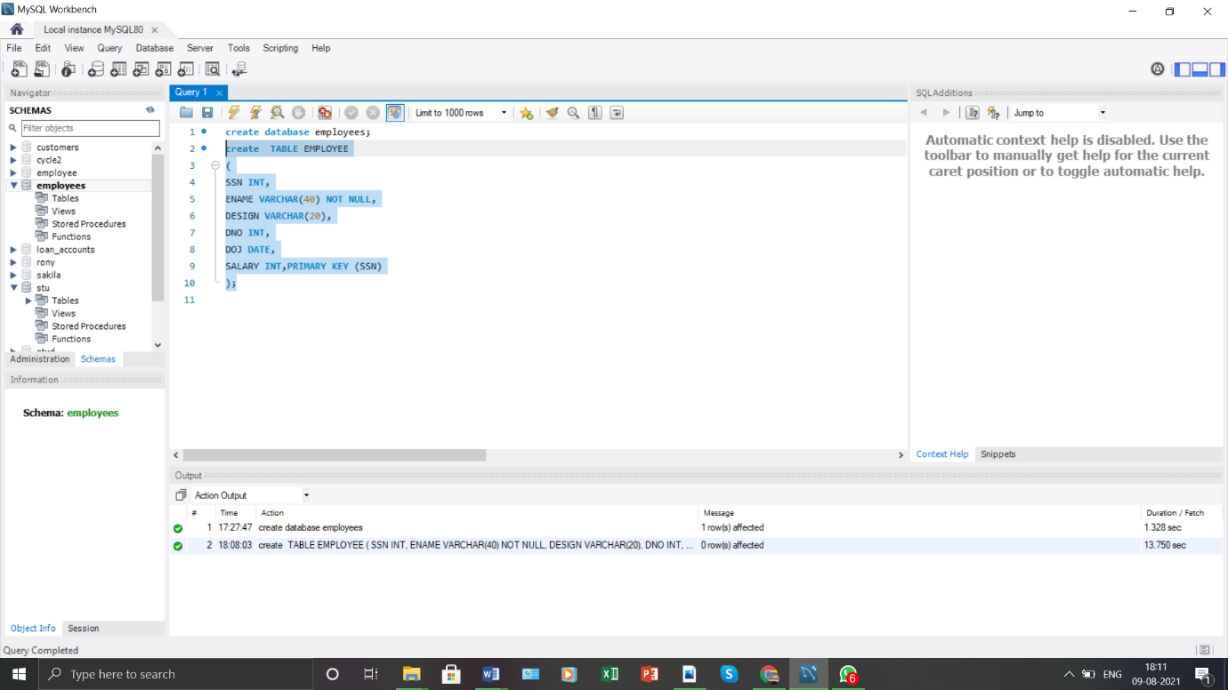

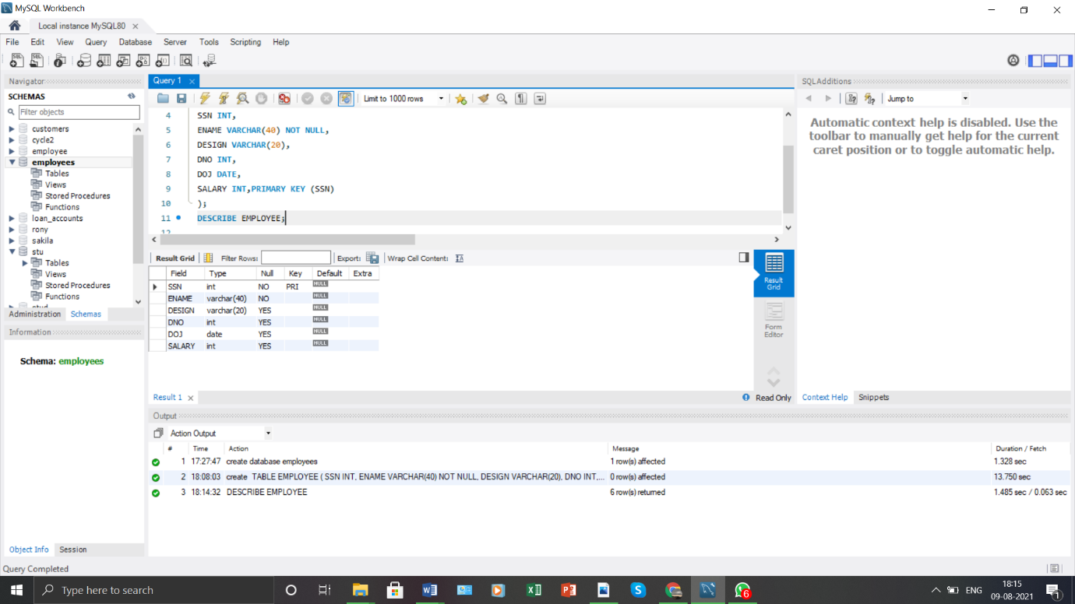

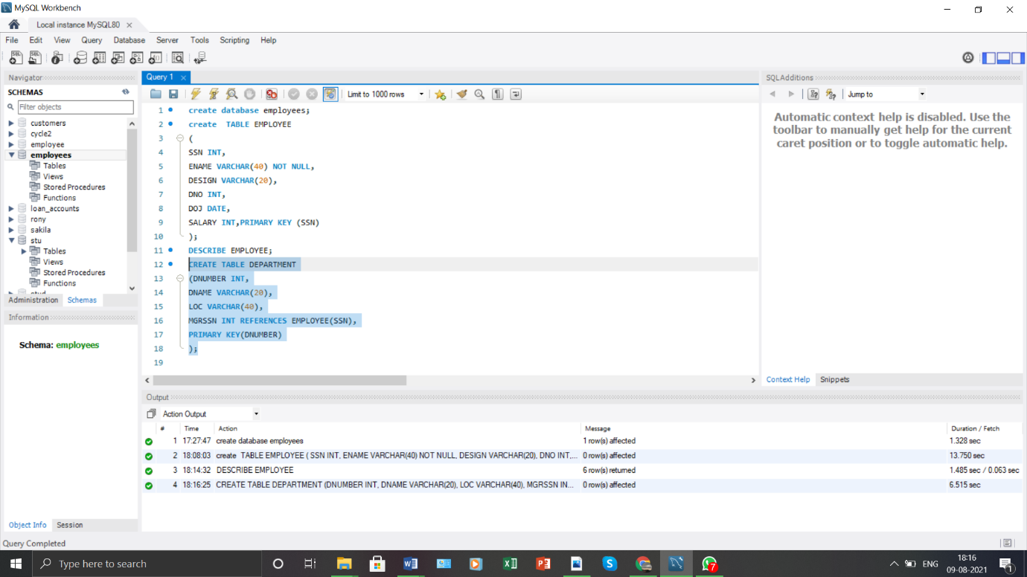

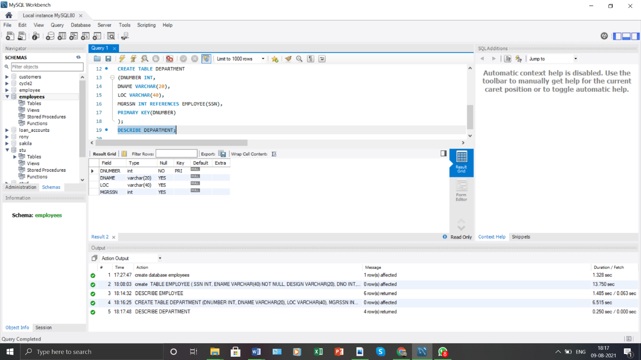

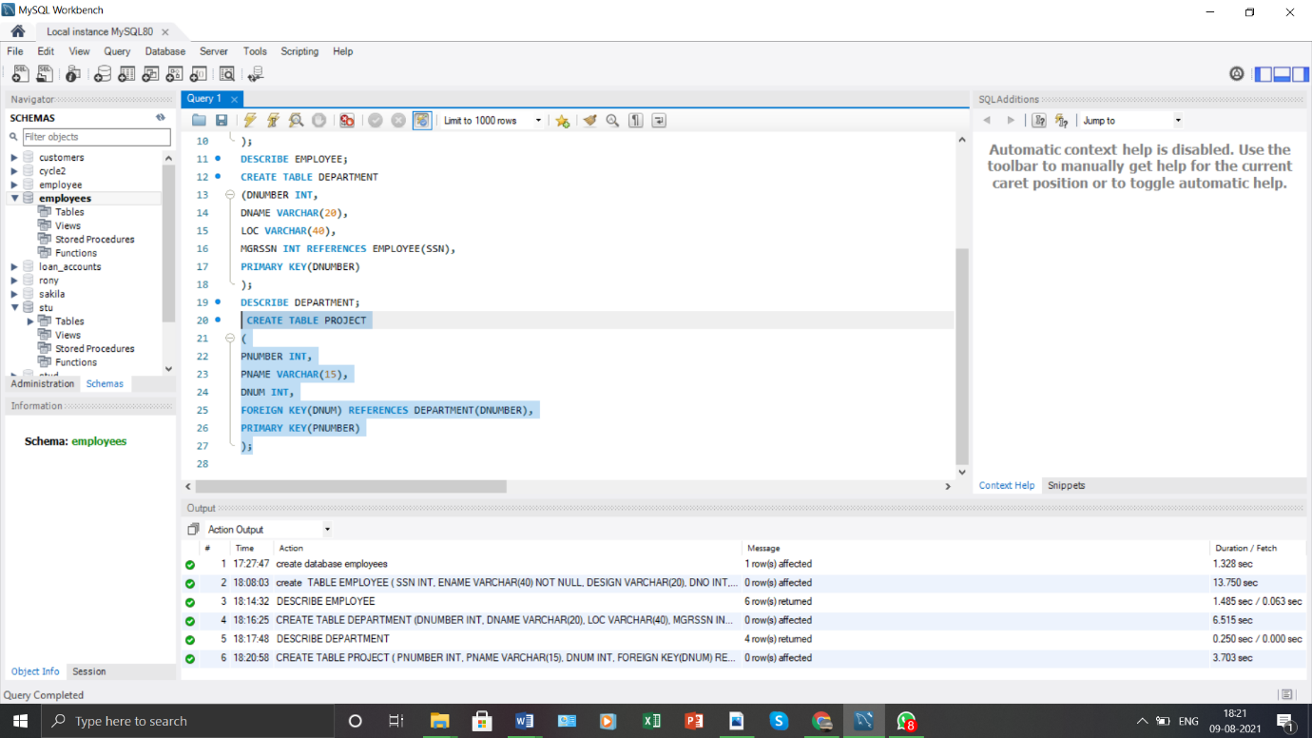

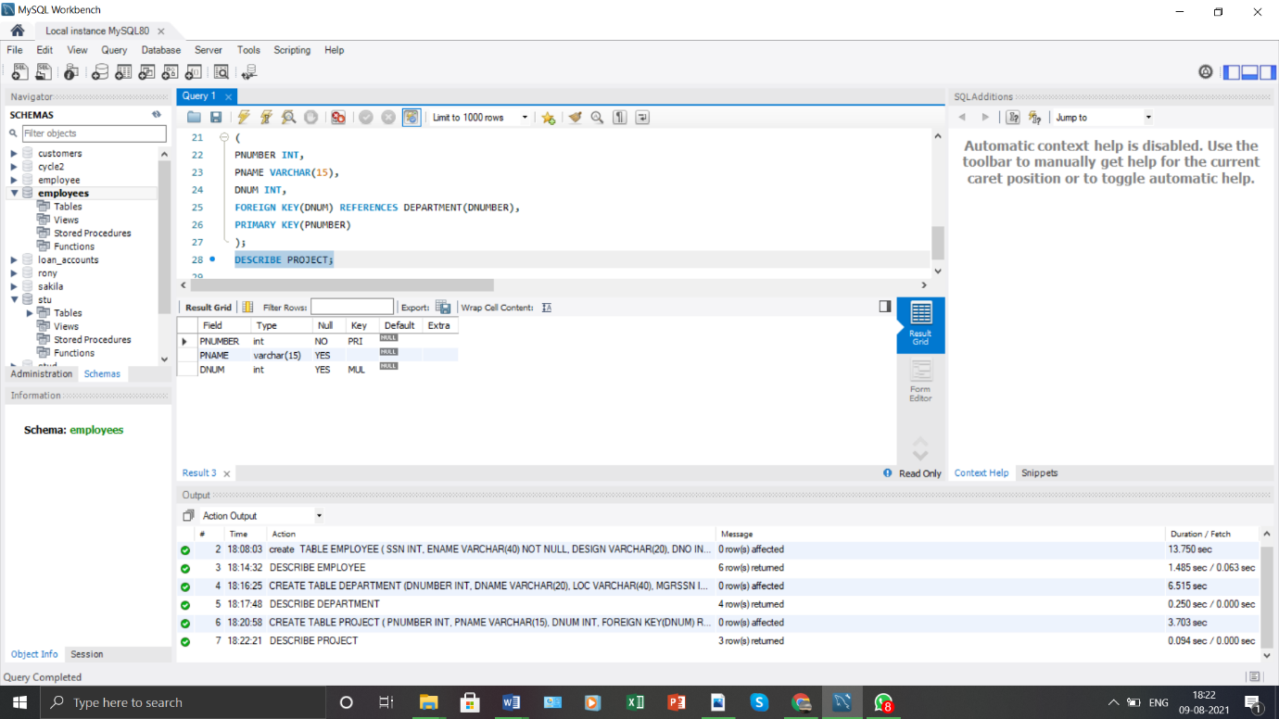

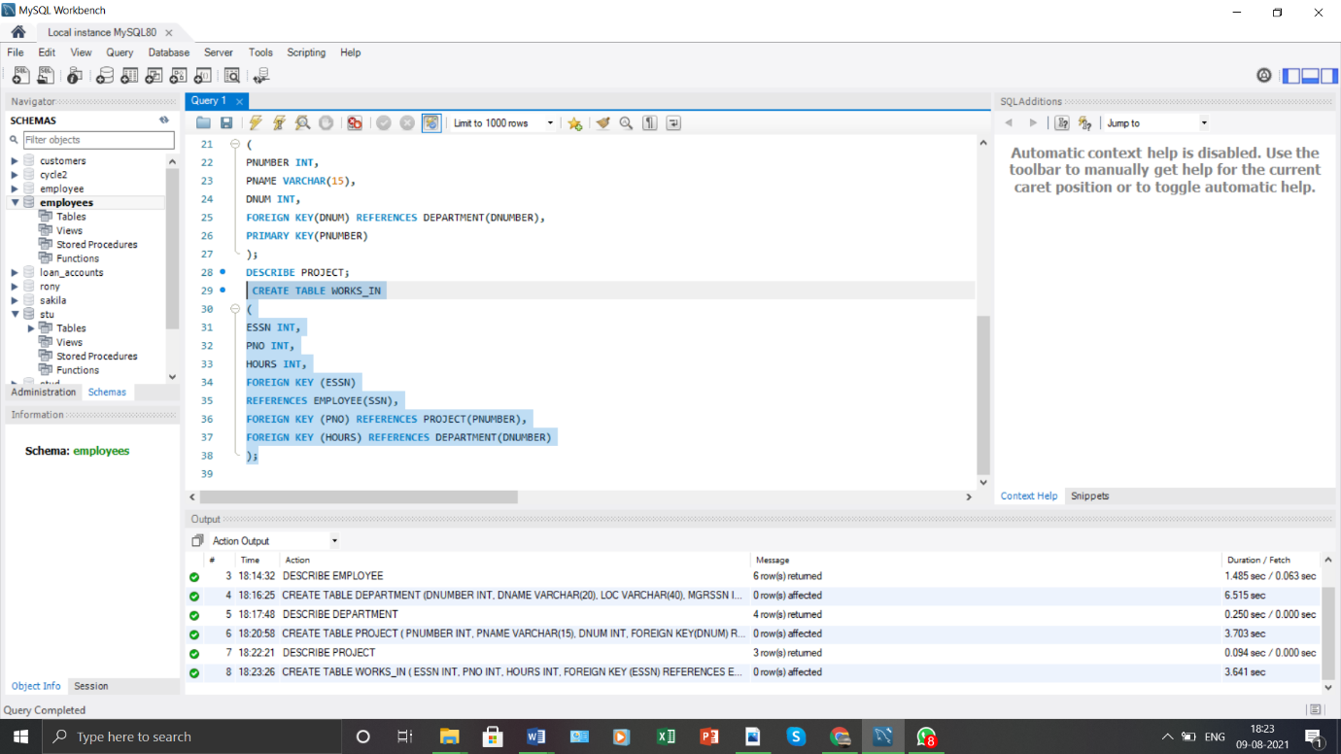

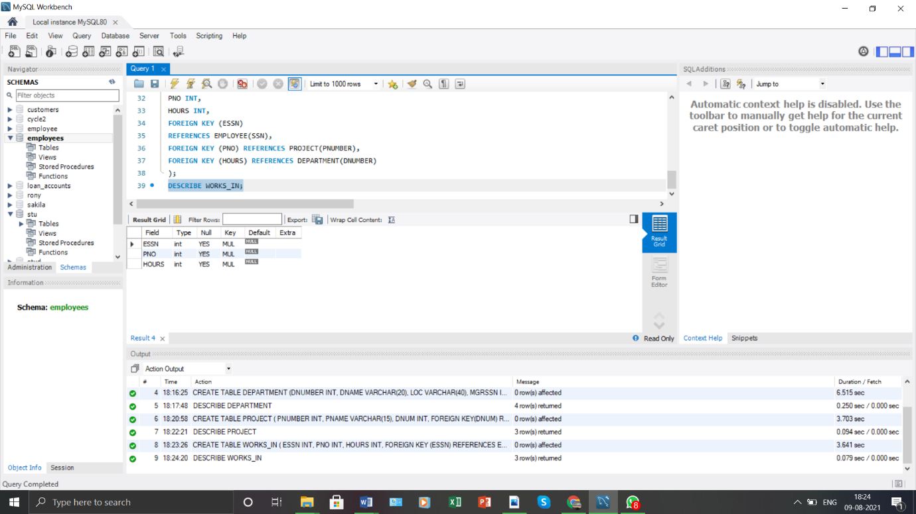

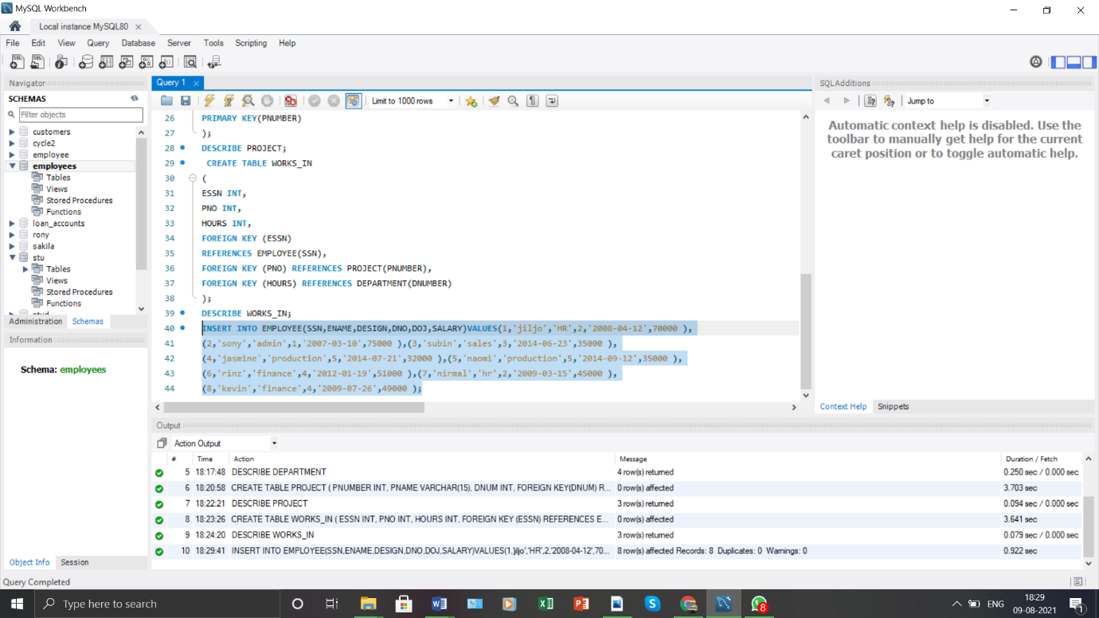

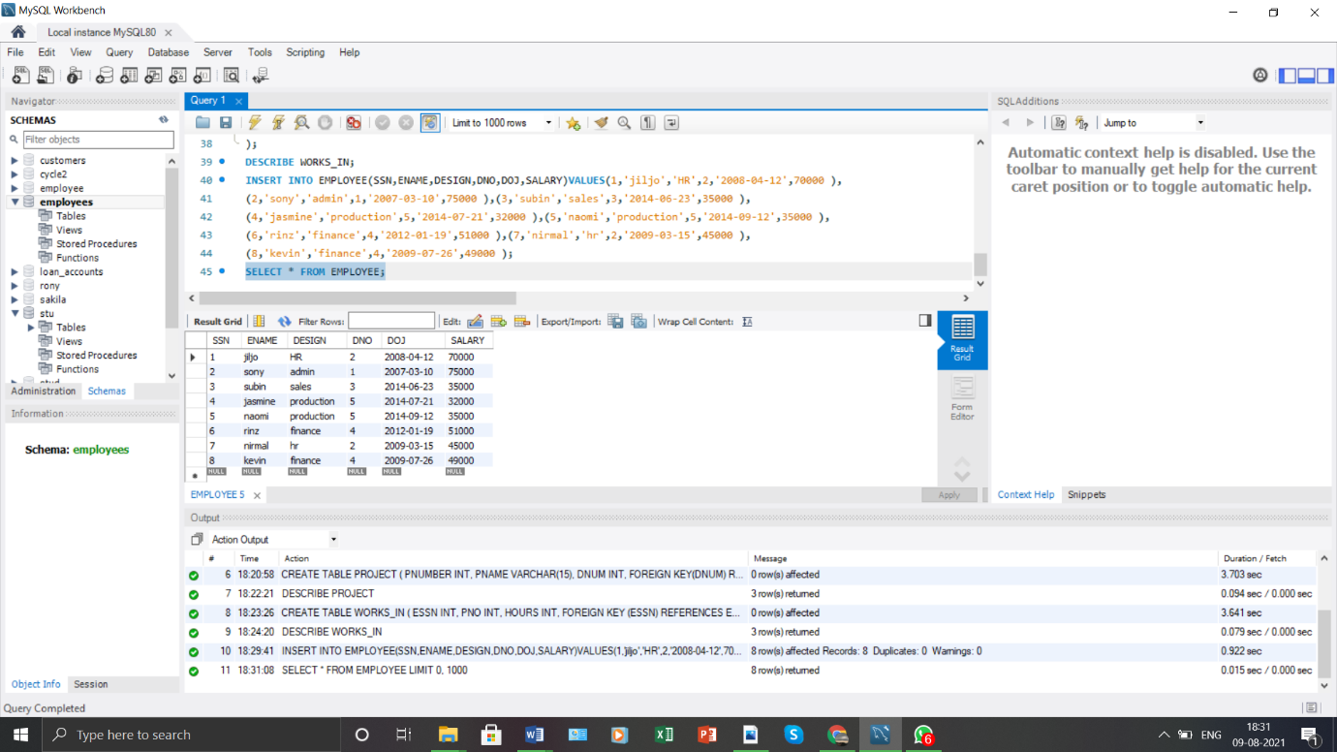

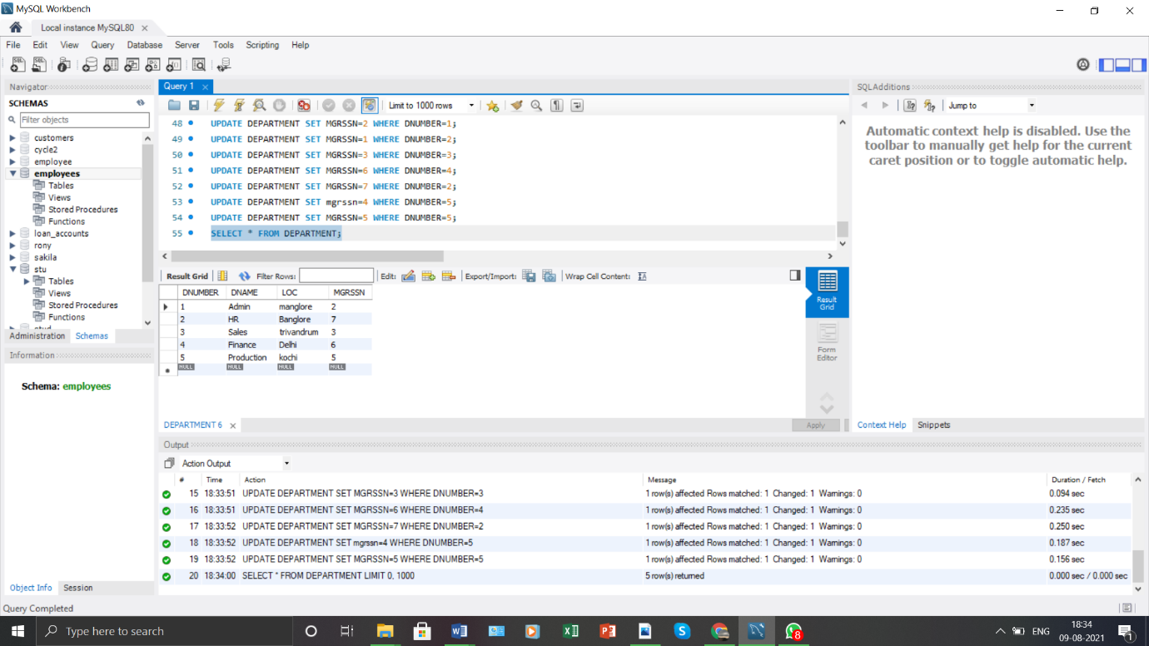

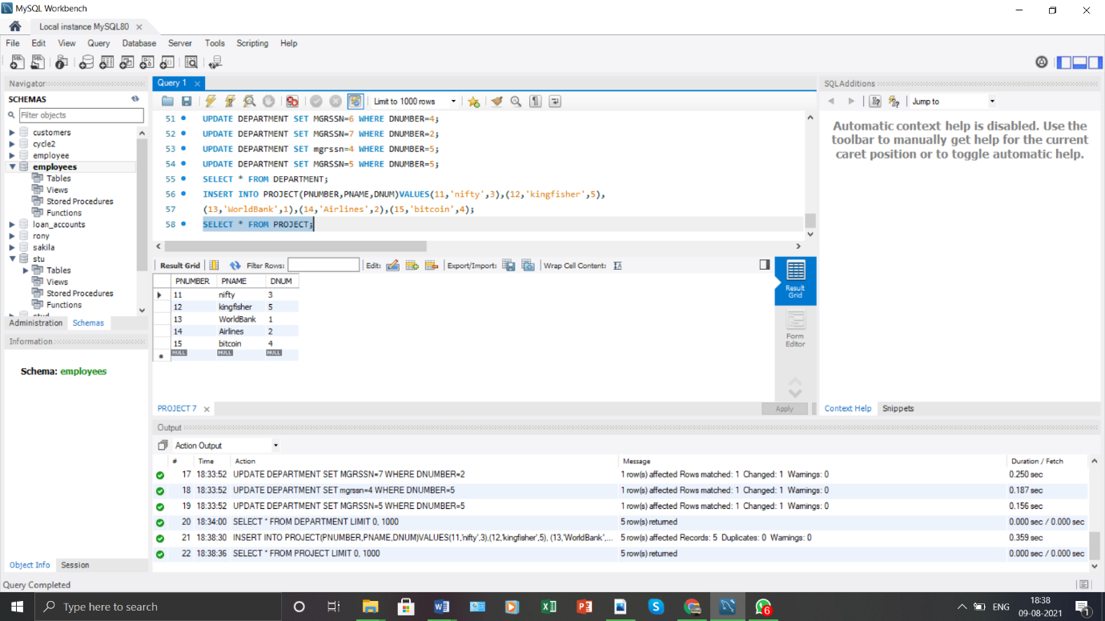

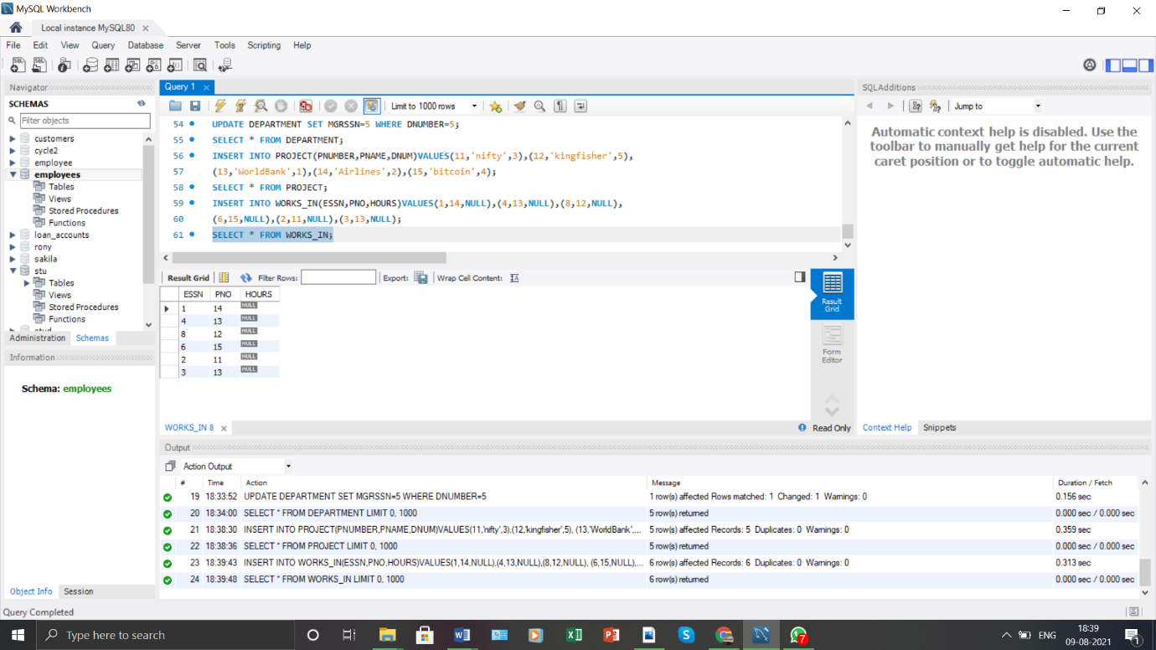

**1.**

Retrieve all employees in department 5 whose salary is between Rs 30,000 and Rs 40,000.

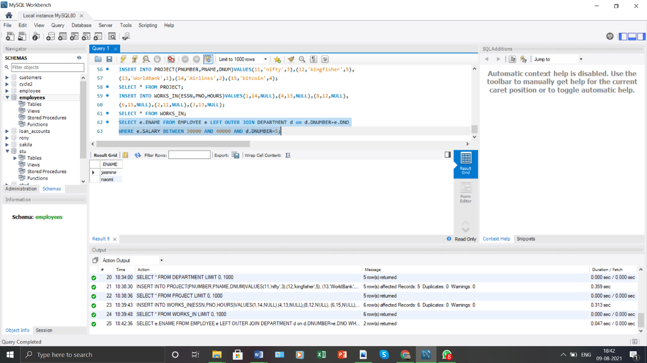

**2.**

Retrieve a list of employees and the projects they are working on, where the departments and the employees within the department are alphabetically by name.

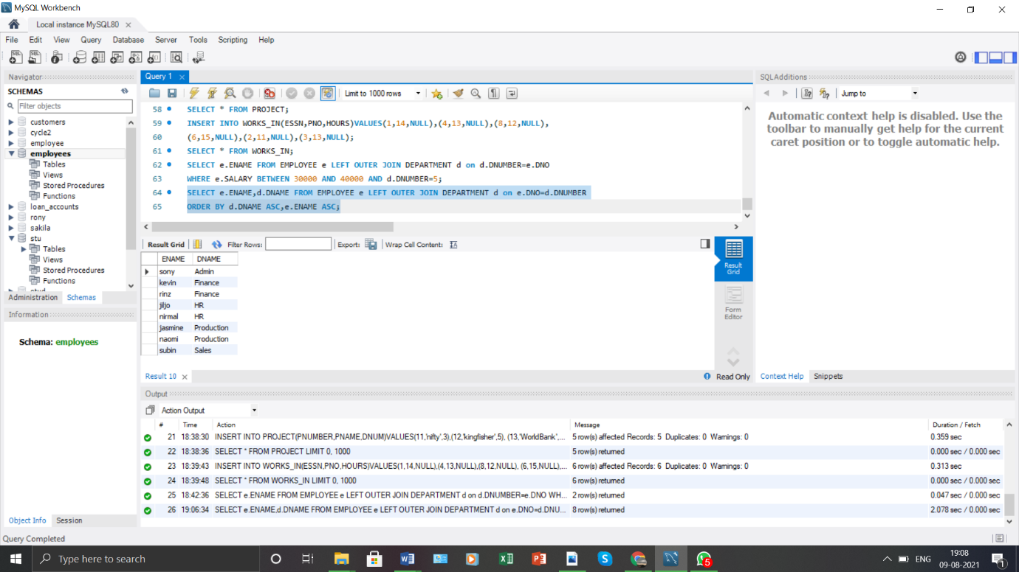

**3.**

Retrieve the project number, the project name, and the number of employees who work in each project.

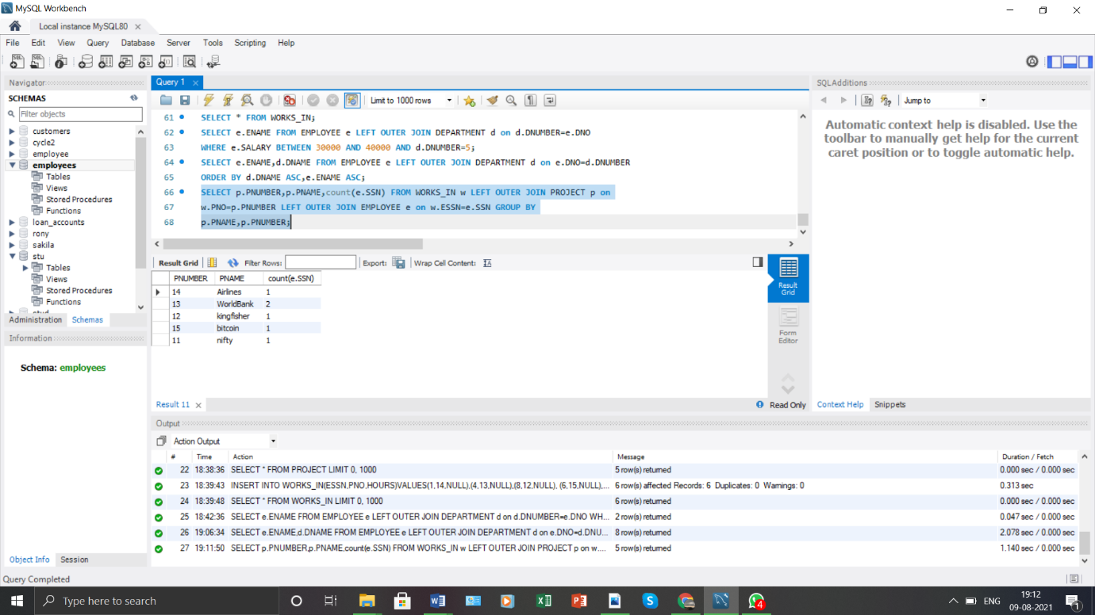

**4.**

For the project on which more than two employees work, retrieve the project number, the project name, and the number of employees who work on the project.

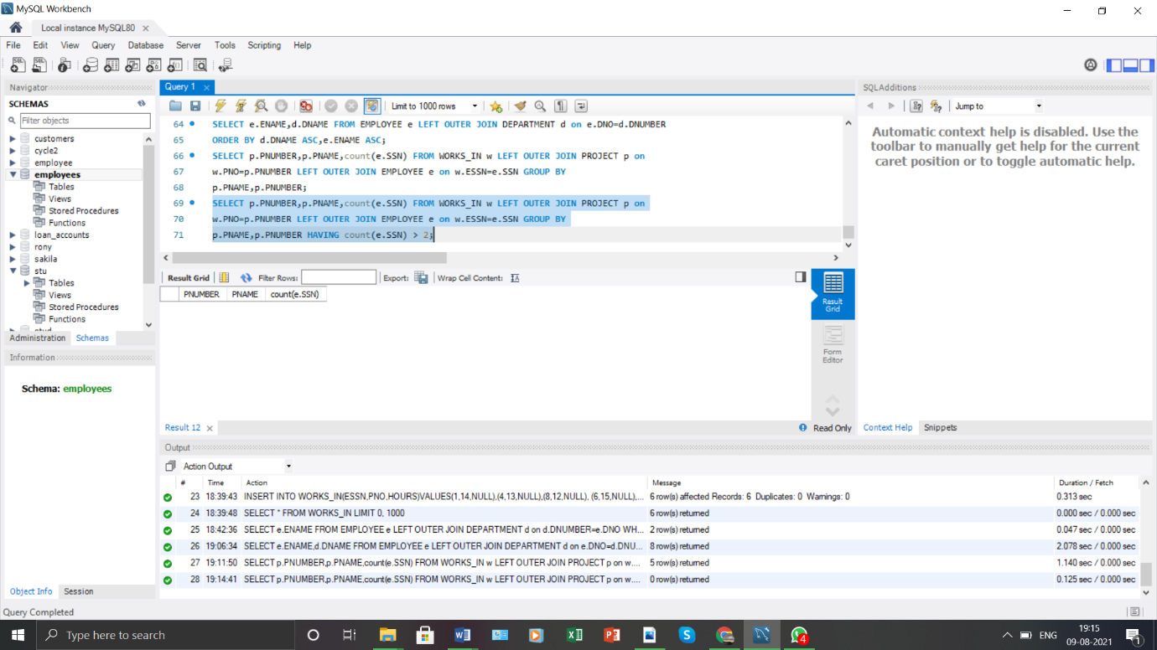

**5.**

For each project, retrieve the project number, the project name, and the number of employees from department 5 who work on the project.

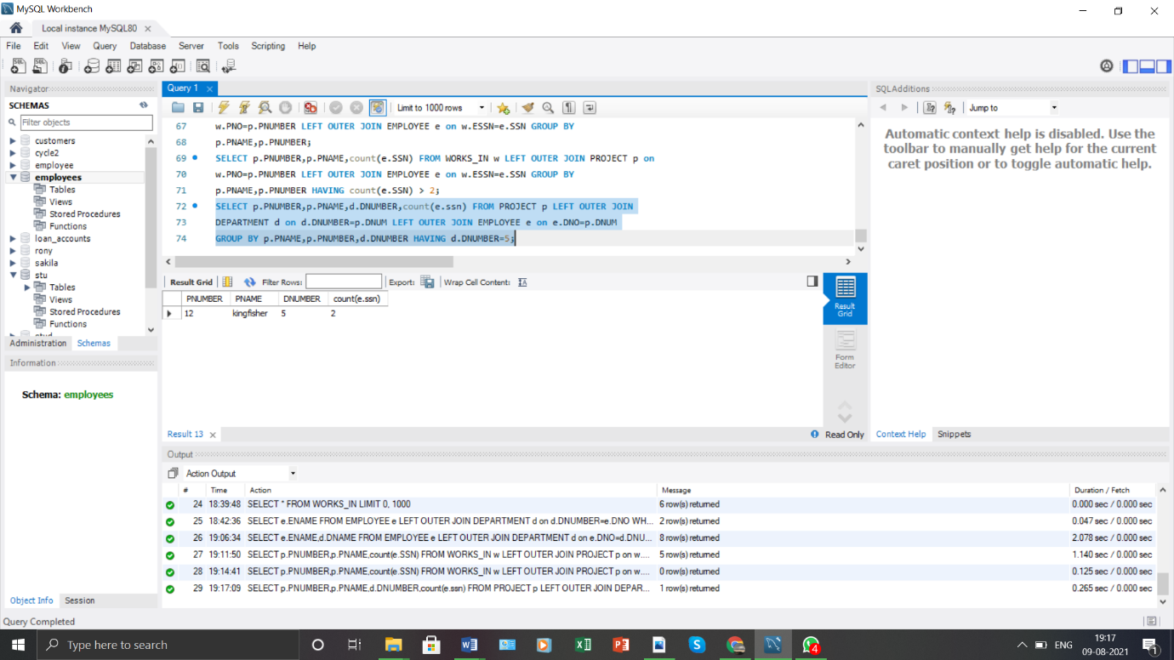

**6.**

For the departments having more than five employees, display the department id and the number and details of employees earning more than Rs 40,000 per month.

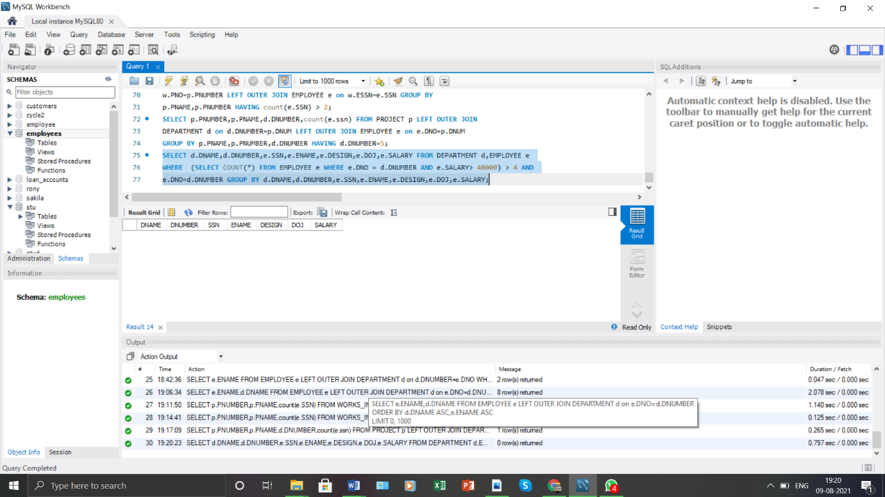

**8.**

Use the tables Employee, and Department. Perform the operations as mentioned below:

1. (a) Display the employee details, departments that the departments are same in

both the emp and dept. (Equi-join)

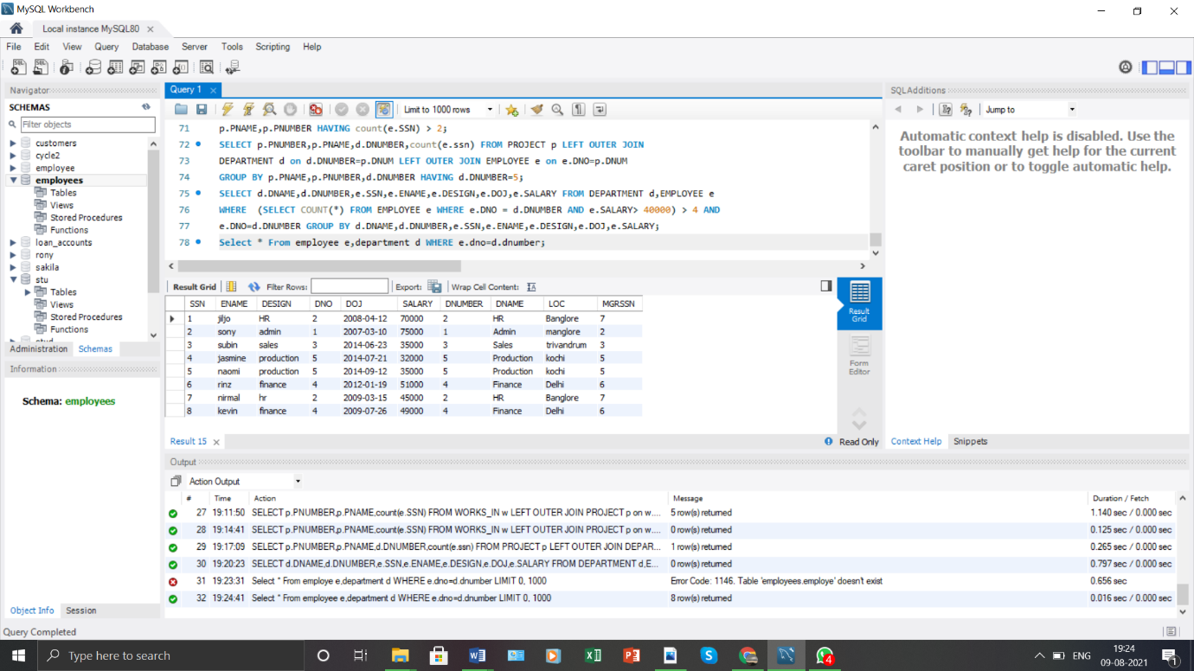

**b.**

1. Display the employee details, departments that the departments are

not same in both the emp and dept. (Non Equi-join)

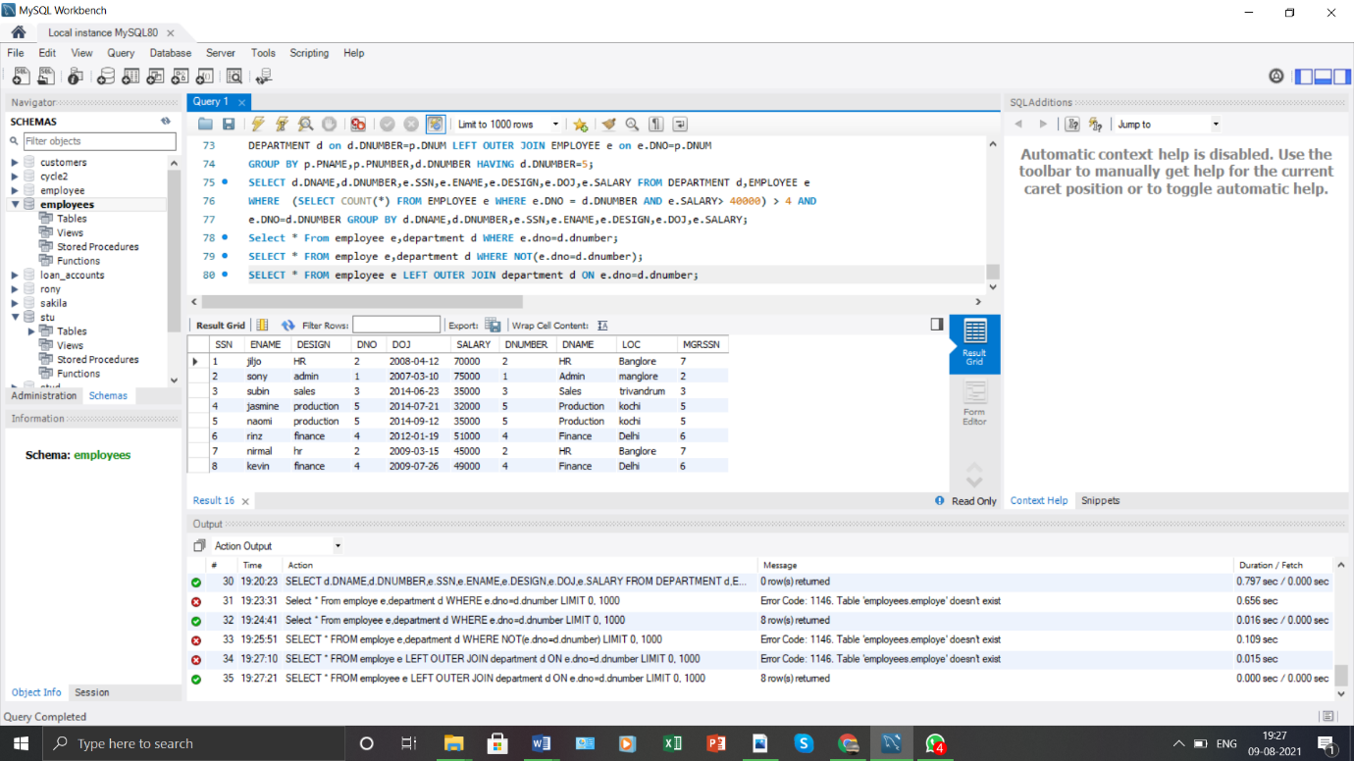

**c.**

1. Perform Left outer join on the emp and dept tables.

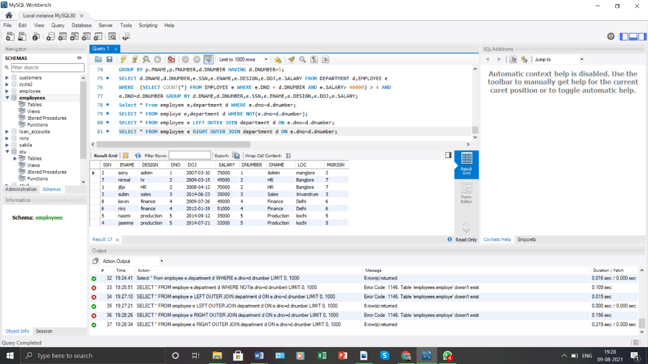

**d.**

1. Perform Right outer join on the emp and dept tables.

